**EXPERIMENT NO.4**

**Title of experiment:** To study and design MUX and DEMUX.

**Equipments required**: Proteus 8

**Theory:**

1) Multiplexer means many into one. A multiplexer is a circuit used to select and route any one of the several input signals to a single output. A simple example of an non-electronic circuit of a multiplexer is a single pole multi-position switch.

2) Demultiplexer means one to many. A demultiplexer is a circuit with one input and many outputs. By applying control signal, we can steer any input to the output. Few types of demultiplexer are 1-to 2, 1-to-4, 1-to-8 and 1-to 16 demultiplexer.

**Implementation:**

1)The AND gate(4081),OR gate(4071),NOR(74S02),XOR(4030),

NOT gate,NAND(4011) are library devices used show the

working of the data in Proteus 8 software.

2)Logicstate,logicprobe devices are used to fetch output

of logic gates.

**Snapshots:**

**MUX**

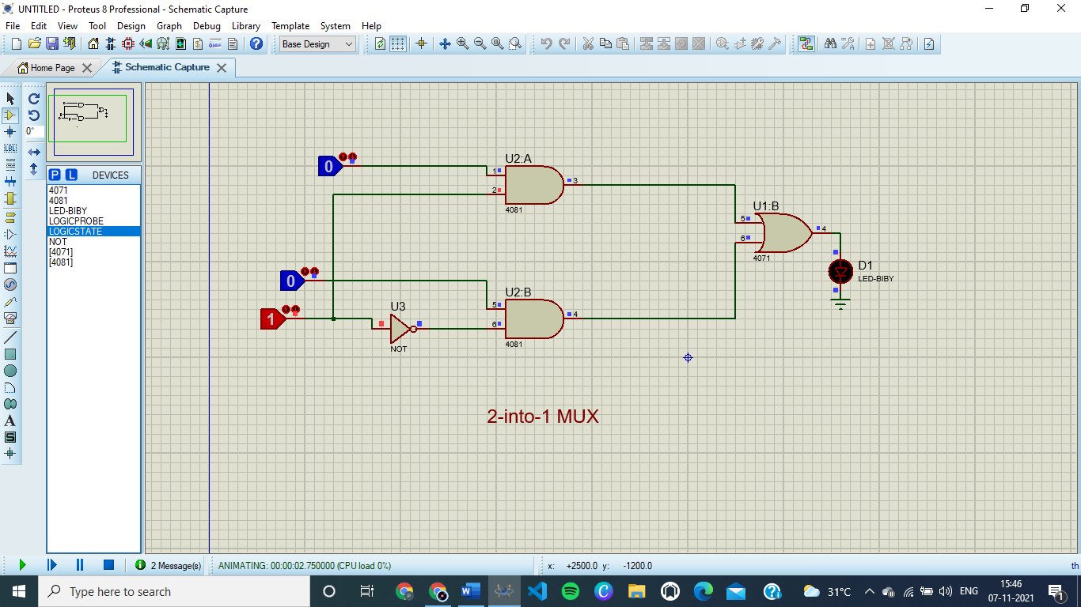

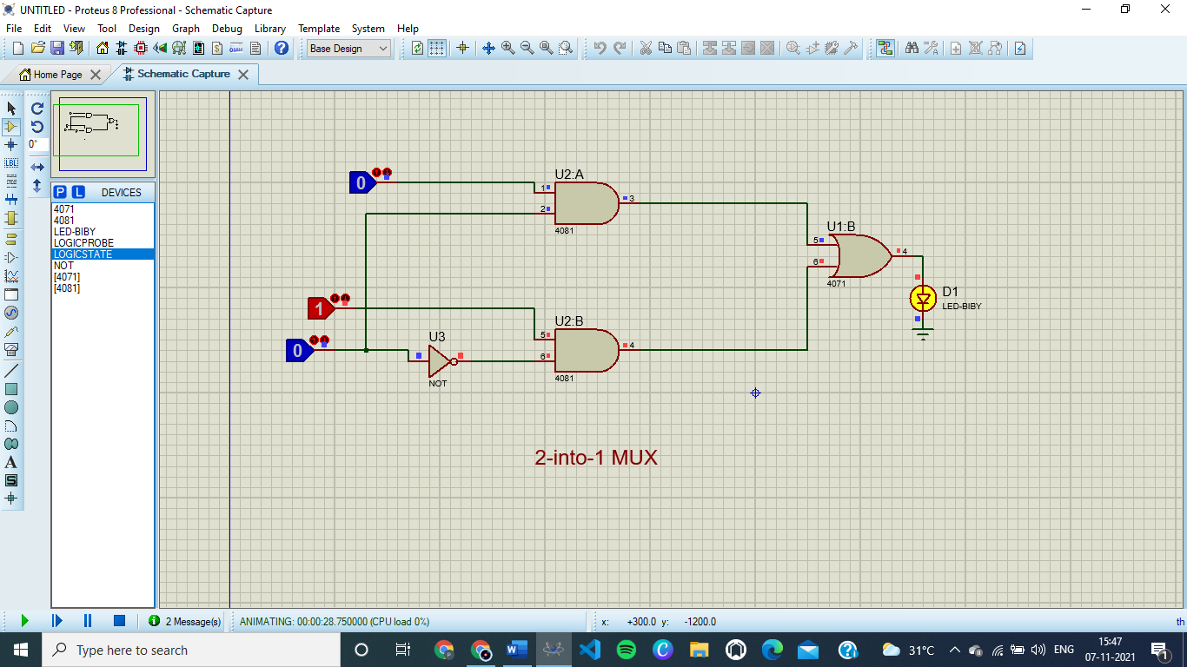

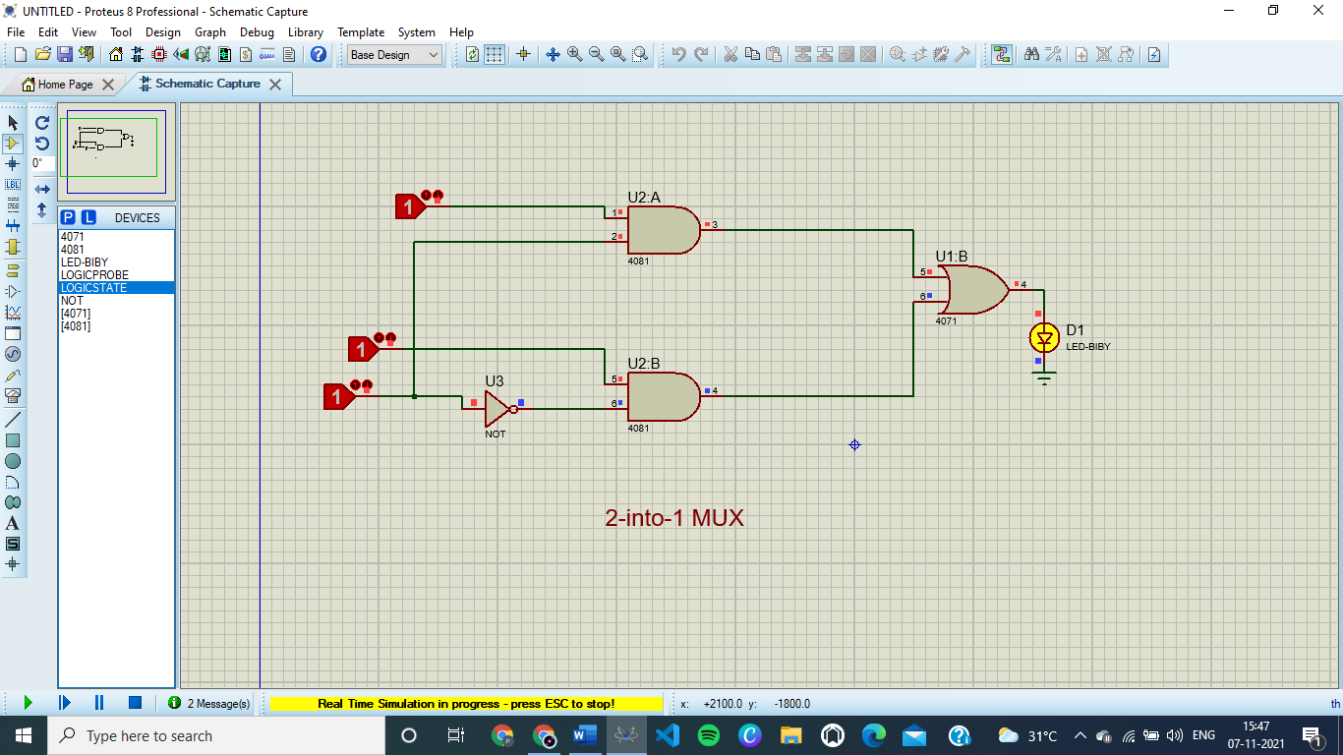

**DEMUX**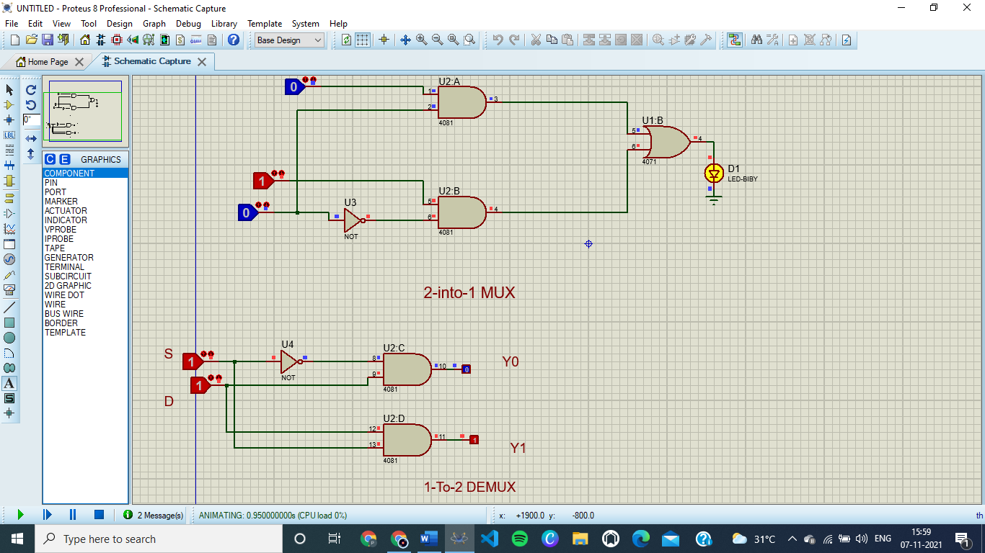

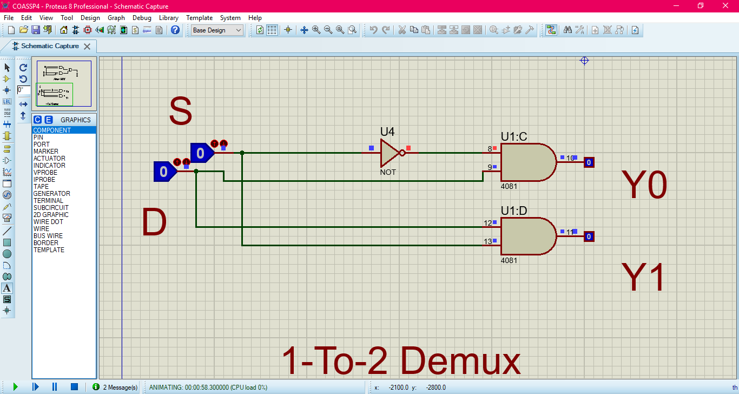

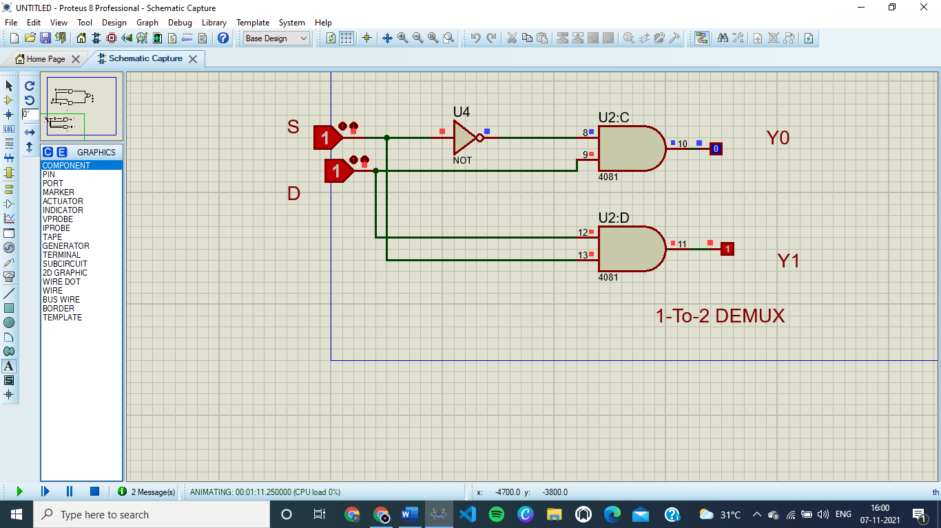

**Conclusion**

These are MUX and DEMUX demos in Proteus